# Task 01

## Code

clc

clear all

close all

% part01

w = logspace(-1,4,20);

H1=100./(j*w + 30);

figure(1)

subplot(2,1,1);

semilogx(w,20*log10(abs(H1)));

xlabel('\omega (rad/sec)')

ylabel('|H(j\omega)|')

title('Bode Plot at jw: Magnitude Response');

grid on

subplot(2,1,2);

semilogx(w,unwrap(angle(H1))*180/pi);

xlabel('\omega (rad/sec)');

ylabel('\angleH(j\omega) (\circ)');

title('Bode Plotfor at jw: Phase Response');

grid on

% part02

w2=(w/10 +1)

H2=100./(j*w2 + 30);

figure(2)

subplot(2,1,1);

semilogx(w2,20*log10(abs(H2)));

xlabel('\omega (rad/sec)')

ylabel('|H(j\omega)|')

title('Bode Plot at (jw/10 +1): Magnitude Response');

grid on

subplot(2,1,2);

semilogx(w2,unwrap(angle(H2))*180/pi);

xlabel('\omega (rad/sec)');

ylabel('\angleH(j\omega) (\circ)');

title('Bode Plotfor at (jw/10 +1): Phase Response');

grid on

% part03

w3=(w/1+1);

H3=100./(j*w3 + 30);

figure(3)

subplot(2,1,1);

semilogx(w3,20*log10(abs(H3)));

xlabel('\omega (rad/sec)')

ylabel('|H(j\omega)|')

title('Bode Plot at (jw/1+1): Magnitude Response');

grid on

subplot(2,1,2);

semilogx(w3,unwrap(angle(H3))*180/pi);

xlabel('\omega (rad/sec)');

ylabel('\angleH(j\omega) (\circ)');

title('Bode Plotfor at (jw/1+1): Phase Response');

grid on

% part04

w4=(w/100+1);

H4=100./(j*w3 + 30);

figure(4)

subplot(2,1,1);

semilogx(w4,20*log10(abs(H4)));

xlabel('\omega (rad/sec)')

ylabel('|H(j\omega)|')

title('Bode Plot at (jw/100+1): Magnitude Response');

grid on

subplot(2,1,2);

semilogx(w4,unwrap(angle(H4))*180/pi);

xlabel('\omega (rad/sec)');

ylabel('\angleH(j\omega) (\circ)');

title('Bode Plotfor at (jw/100+1): Phase Response');

grid on

% overall responce

H=H1+H2+H3+H4;

figure(5)

subplot(2,1,1);

semilogx(w,20*log10(abs(H)));

xlabel('\omega (rad/sec)')

ylabel('|H(j\omega)|')

title('Bode Plot Overall: Magnitude Response');

grid on

subplot(2,1,2);

semilogx(w,unwrap(angle(H))*180/pi);

xlabel('\omega (rad/sec)');

ylabel('\angleH(j\omega) (\circ)');

title('Bode Plotfor Overall: Phase Response');

grid on

## Output

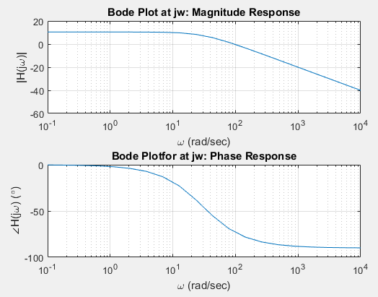

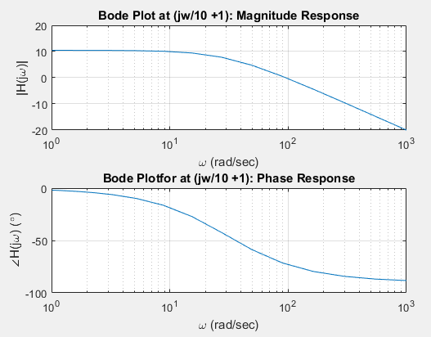

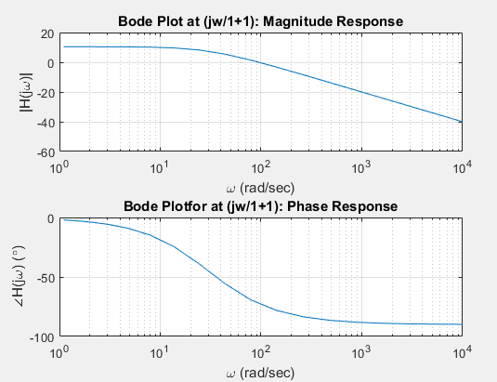

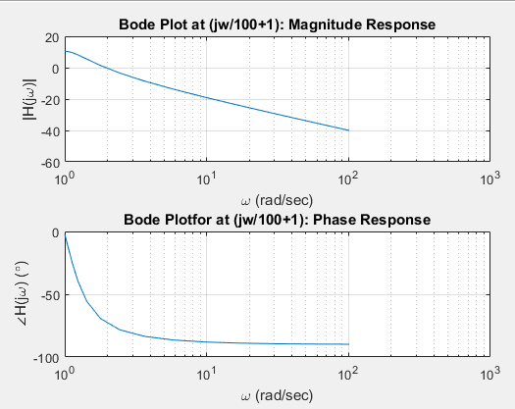

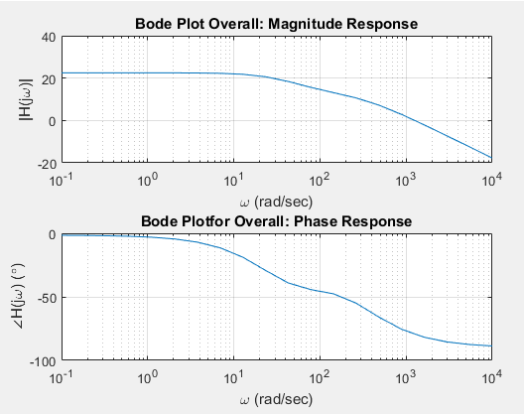

# Task 02

## Code

clc

clear all

close all

w = logspace(-1,4,200);

H1=(j*w+ 1)./(j*w.^2 + 110*j.*w + 1000) * 100 ;

figure(1)

subplot(2,1,1);

semilogx(w,20*log10(abs(H1)));

xlabel('\omega (rad/sec)')

ylabel('|H(j\omega)|')

title('Bode Plot at jw: Magnitude Response');

grid on

subplot(2,1,2);

semilogx(w,unwrap(angle(H1))*180/pi);

xlabel('\omega (rad/sec)');

ylabel('\angleH(j\omega) (\circ)');

title('Bode Plotfor at jw: Phase Response');

grid on

% part02

w2=(w/10 +1)

H2=(j*w2+ 1)./(j*w2.^2 + 110*j.*w2 + 1000) * 100;

figure(2)

subplot(2,1,1);

semilogx(w2,20*log10(abs(H2)));

xlabel('\omega (rad/sec)')

ylabel('|H(j\omega)|')

title('Bode Plot at (jw/10 +1): Magnitude Response');

grid on

subplot(2,1,2);

semilogx(w2,unwrap(angle(H2))*180/pi);

xlabel('\omega (rad/sec)');

ylabel('\angleH(j\omega) (\circ)');

title('Bode Plotfor at (jw/10 +1): Phase Response');

grid on

% part03

w3=(w/1+1);

H3=(j*w3+ 1)./(j*w3.^2 + 110*j.*w3 + 1000) * 100

figure(3)

subplot(2,1,1);

semilogx(w3,20*log10(abs(H3)));

xlabel('\omega (rad/sec)')

ylabel('|H(j\omega)|')

title('Bode Plot at (jw/1+1): Magnitude Response');

grid on

subplot(2,1,2);

semilogx(w3,unwrap(angle(H3))*180/pi);

xlabel('\omega (rad/sec)');

ylabel('\angleH(j\omega) (\circ)');

title('Bode Plotfor at (jw/1+1): Phase Response');

grid on

% part04

w4=(w/100+1);

H4=(j*w4+ 1)./(j*w4.^2 + 110*j.*w4 + 1000) * 100

figure(4)

subplot(2,1,1);

semilogx(w4,20*log10(abs(H4)));

xlabel('\omega (rad/sec)')

ylabel('|H(j\omega)|')

title('Bode Plot at (jw/100+1): Magnitude Response');

grid on

subplot(2,1,2);

semilogx(w4,unwrap(angle(H4))*180/pi);

xlabel('\omega (rad/sec)');

ylabel('\angleH(j\omega) (\circ)');

title('Bode Plotfor at (jw/100+1): Phase Response');

grid on

% overall responce

H=H1+H2+H3+H4;

figure(5)

subplot(2,1,1);

semilogx(w,20*log10(abs(H)));

xlabel('\omega (rad/sec)')

ylabel('|H(j\omega)|')

title('Bode Plot Overall: Magnitude Response');

grid on

subplot(2,1,2);

semilogx(w,unwrap(angle(H))*180/pi);

xlabel('\omega (rad/sec)');

ylabel('\angleH(j\omega) (\circ)');

title('Bode Plotfor Overall: Phase Response');

grid on

## Output

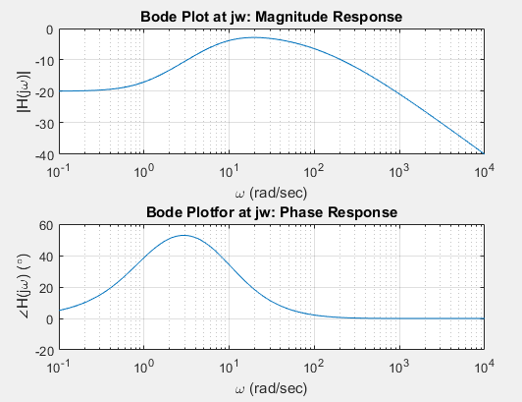

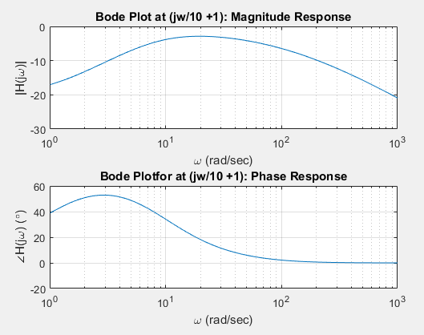

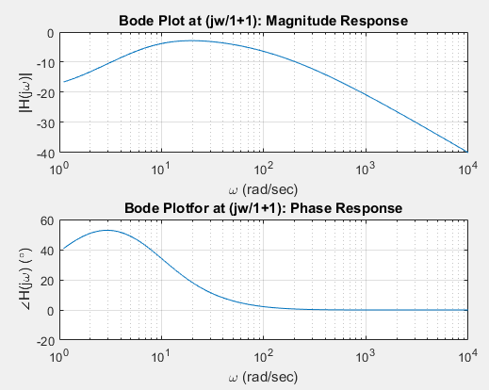

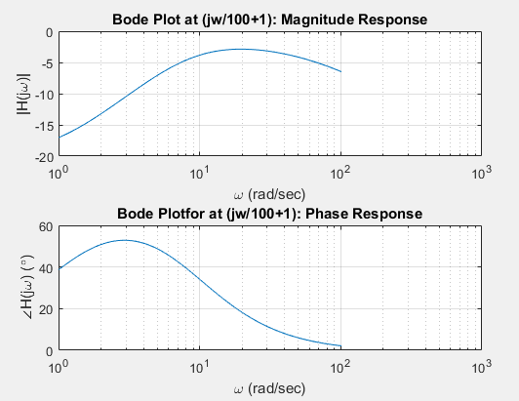

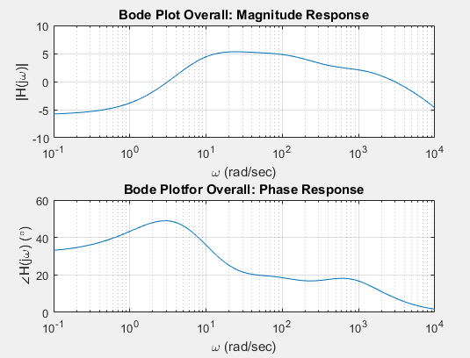

# Task 03

## Code

clc

clear all

close all

w = logspace(-1,4,200);

H1=(j.*w +10)./(j*w.^2 + 3*j.*w);

figure(1)

subplot(2,1,1);

semilogx(w,20*log10(abs(H1)));

xlabel('\omega (rad/sec)')

ylabel('|H(j\omega)|')

title('Bode Plot at jw: Magnitude Response');

grid on

subplot(2,1,2);

semilogx(w,unwrap(angle(H1))*180/pi);

xlabel('\omega (rad/sec)');

ylabel('\angleH(j\omega) (\circ)');

title('Bode Plotfor at jw: Phase Response');

grid on

% part02

w2=(w/10 +1)

H2=(j.*w +10)./(j*w.^2 + 3*j.*w);

figure(2)

subplot(2,1,1);

semilogx(w2,20*log10(abs(H2)));

xlabel('\omega (rad/sec)')

ylabel('|H(j\omega)|')

title('Bode Plot at (jw/10 +1): Magnitude Response');

grid on

subplot(2,1,2);

semilogx(w2,unwrap(angle(H2))*180/pi);

xlabel('\omega (rad/sec)');

ylabel('\angleH(j\omega) (\circ)');

title('Bode Plotfor at (jw/10 +1): Phase Response');

grid on

% part03

w3=(w/1+1);

H3=(j.*w +10)./(j*w.^2 + 3*j.*w);

figure(3)

subplot(2,1,1);

semilogx(w3,20*log10(abs(H3)));

xlabel('\omega (rad/sec)')

ylabel('|H(j\omega)|')

title('Bode Plot at (jw/1+1): Magnitude Response');

grid on

subplot(2,1,2);

semilogx(w3,unwrap(angle(H3))*180/pi);

xlabel('\omega (rad/sec)');

ylabel('\angleH(j\omega) (\circ)');

title('Bode Plotfor at (jw/1+1): Phase Response');

grid on

% part04

w4=(w/100+1);

H4=(j.*w +10)./(j*w.^2 + 3*j.*w);

figure(4)

subplot(2,1,1);

semilogx(w4,20*log10(abs(H4)));

xlabel('\omega (rad/sec)')

ylabel('|H(j\omega)|')

title('Bode Plot at (jw/100+1): Magnitude Response');

grid on

subplot(2,1,2);

semilogx(w4,unwrap(angle(H4))*180/pi);

xlabel('\omega (rad/sec)');

ylabel('\angleH(j\omega) (\circ)');

title('Bode Plotfor at (jw/100+1): Phase Response');

grid on

% overall responce

H=H1+H2+H3+H4;

figure(5)

subplot(2,1,1);

semilogx(w,20*log10(abs(H)));

xlabel('\omega (rad/sec)')

ylabel('|H(j\omega)|')

title('Bode Plot Overall: Magnitude Response');

grid on

subplot(2,1,2);

semilogx(w,unwrap(angle(H))*180/pi);

xlabel('\omega (rad/sec)');

ylabel('\angleH(j\omega) (\circ)');

title('Bode Plotfor Overall: Phase Response');

grid on

## Output

## 

## 

## 

## 

## 

# Task 04

## Code

clc

clear all

close all

w = logspace(-1,4,200);

H1=(j.*w)./(j*w.^3 + 12j.*w.^2 + 21j.*w + 10).*(-100);

figure(1)

subplot(2,1,1);

semilogx(w,20*log10(abs(H1)));

xlabel('\omega (rad/sec)')

ylabel('|H(j\omega)|')

title('Bode Plot at jw: Magnitude Response');

grid on

subplot(2,1,2);

semilogx(w,unwrap(angle(H1))*180/pi);

xlabel('\omega (rad/sec)');

ylabel('\angleH(j\omega) (\circ)');

title('Bode Plotfor at jw: Phase Response');

grid on

% part02

w2=(w/10 +1)

H2=(j.*w)./(j*w.^3 + 12j.*w.^2 + 21j.*w + 10).*(-100);

figure(2)

subplot(2,1,1);

semilogx(w2,20*log10(abs(H2)));

xlabel('\omega (rad/sec)')

ylabel('|H(j\omega)|')

title('Bode Plot at (jw/10 +1): Magnitude Response');

grid on

subplot(2,1,2);

semilogx(w2,unwrap(angle(H2))*180/pi);

xlabel('\omega (rad/sec)');

ylabel('\angleH(j\omega) (\circ)');

title('Bode Plotfor at (jw/10 +1): Phase Response');

grid on

% part03

w3=(w/1+1);

H3=(j.*w)./(j*w.^3 + 12j.*w.^2 + 21j.*w + 10).*(-100);

figure(3)

subplot(2,1,1);

semilogx(w3,20*log10(abs(H3)));

xlabel('\omega (rad/sec)')

ylabel('|H(j\omega)|')

title('Bode Plot at (jw/1+1): Magnitude Response');

grid on

subplot(2,1,2);

semilogx(w3,unwrap(angle(H3))*180/pi);

xlabel('\omega (rad/sec)');

ylabel('\angleH(j\omega) (\circ)');

title('Bode Plotfor at (jw/1+1): Phase Response');

grid on

% part04

w4=(w/100+1);

H4=(j.*w)./(j*w.^3 + 12j.*w.^2 + 21j.*w + 10).*(-100);

figure(4)

subplot(2,1,1);

semilogx(w4,20*log10(abs(H4)));

xlabel('\omega (rad/sec)')

ylabel('|H(j\omega)|')

title('Bode Plot at (jw/100+1): Magnitude Response');

grid on

subplot(2,1,2);

semilogx(w4,unwrap(angle(H4))*180/pi);

xlabel('\omega (rad/sec)');

ylabel('\angleH(j\omega) (\circ)');

title('Bode Plotfor at (jw/100+1): Phase Response');

grid on

% overall responce

H=H1+H2+H3+H4;

figure(5)

subplot(2,1,1);

semilogx(w,20*log10(abs(H)));

xlabel('\omega (rad/sec)')

ylabel('|H(j\omega)|')

title('Bode Plot Overall: Magnitude Response');

grid on

subplot(2,1,2);

semilogx(w,unwrap(angle(H))*180/pi);

xlabel('\omega (rad/sec)');

ylabel('\angleH(j\omega) (\circ)');

title('Bode Plotfor Overall: Phase Response');

grid on

## Output

